ABINAV S T

230701007

EXP NO:9 Bankers Deadlock Avoidance algorithms

PROGRAM

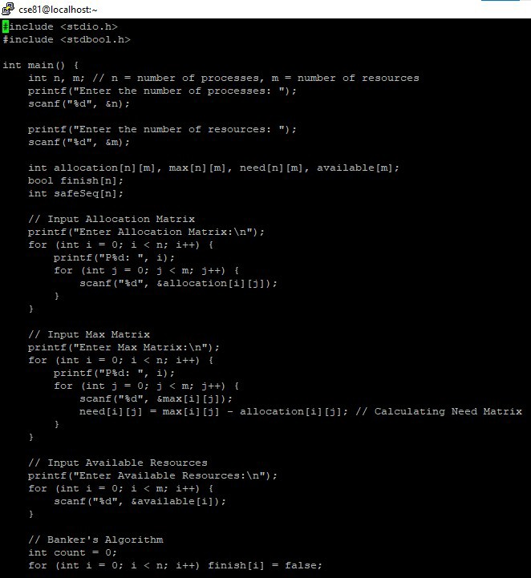

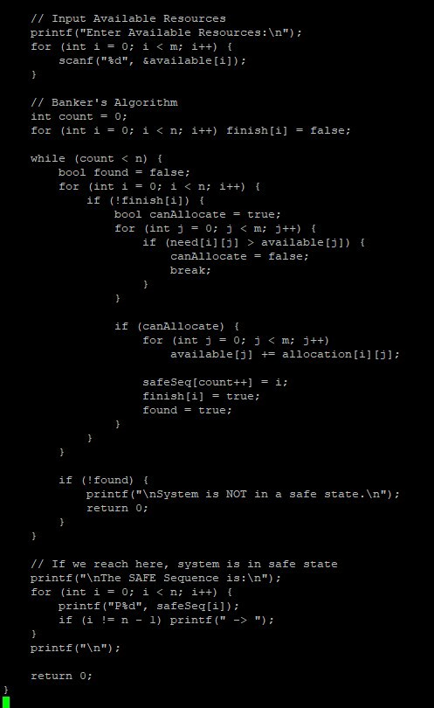

OUTPUT

